×

Top of Form

21E-20CSP-155_20IS_C

COMPUTER WORKSHOP

COMPUTER WORKSHOP

Bottom of Form

Experiment 5: Basics of Computer Hardware and Software

Experiment 5: Basics of Computer Hardware and Software

* 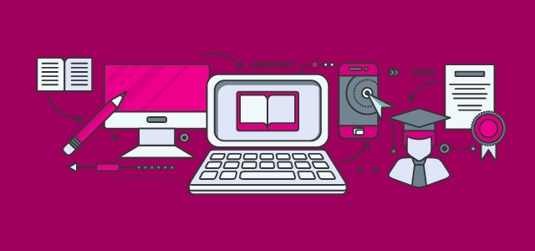

**LEARNING OUTCOME**

After completion of this experiment, student will be able to:

* 1. Understand the basic concept and structure of computer hardware
  2. Identify the existing configuration of the computers and peripherals.

**1.1 COMPUTER**

According to Wikipedia, a computer is a machine that can be instructed to carry out sequences of arithmetic or logical operations automatically via computer programming.

Modern computers have the ability to follow generalized sets of operations, called programs. These programs enable computers to perform an extremely wide range of tasks.

A "complete" computer including the hardware, the operating system (main software), and peripheral equipment required and used for "full" operation can be referred to as a computer system.

**1.2 COMPUTER CLUSTER**

This term may as well be used for a group of computers that are connected and work together, in particular a computer network or computer cluster.

**1.3 COMPUTER HARDWARE AND SOFTWARE**

***1.3.1 Computer Hardware***

A computer is a combination of two terms Hardware and Software. The physical components of a computer are called hardware. Pieces of hardware may be categorized according to the functions each performs: input, process, output, and storage. Your PC (Personal Computer) is a system, consisting of many components. Some of those components, like Windows XP, and all your other programs, are software. Software is the source of interaction between the user and the computer. It represents programs, collection of several sets of instructions, which allow the hardware to run properly.

For convenience, the hardware of a computer can be classified in the following categories:

1. Input Devices

2. Output Devices

3. Central Processing Unit (CPU)

4. Memory or Storage

5. Motherboard

Let us discuss each of these hardware components:

**1. Input Devices:** The form in which data is available to a user is not always in the same form as is accepted by computer hardware. Input devices are hardware equipment that receive data and instructions from users, convert the data and instructions into a form that can be processed by the computer and passes the same to the computer. Hence, if you have to enter employees’ names into the computer you do not have to write it on a piece of paper and shove the paper inside the computer. You will need some input device for this.

*Example: A keyboard is an example of input device.*

*Keyboards are of two sizes 84 keys or 101/102 keys, but now 104 keys or 108 keys keyboard is also available for Windows and Internet.*

**2. Output Devices:** The result, produced by a computer after processing, is not always in user readable form. An output device is hardware equipment that translates this non-readable result into a form understood by the users.

*Example: A VDU (Visual Display Unit) or monitor is an example of output device.*

**3. Central Processing Unit (CPU):** Central processing unit is to computer what brain is to our body. It is the master organ of a computer. No computer can exist without a CPU. It is composed of two simpler hardware units - Arithmetic Logic Unit (ALU) and Control Unit (CU). CU controls all the activities of other hardware units while ALU performs all the calculations. Computer CPUs are very fast in their calculations and swift in control.

**4. Memory or Storage:** This hardware is the place where a computer stores all the data and instructions given to it. The results of the processing are also stored here. A computer has many types of memories. Some memories are directly connected to the CPU and are extremely fast as far as storage and retrieval of data is concerned. These memories are called primary memory - RAM (Random Access Memories) and ROM (Read Only Memories) belong to this category of memories. The CPU takes data and instructions stored only in the primary memories.

**5. Motherboard:** Motherboard, also called as System Board, is the most important hardware Notes component of a microcomputer. Motherboard is so called as all the other boards (printed circuit boards having chips or other electronic components) of the computer are connected to this board, hence it is like the mother of all other boards.

***1.3.2 Computer Software***

By definition, a Software (also abbreviated as an SW or S/W) is a collection of data, programs, procedures, instructions, and documentation that perform various predefined tasks on a computer system. They enable users to interact with the computer

***Types of Computer Software***

The software includes libraries, programs, and corresponding non-executable data, such as digital media and online documentation. Computer hardware and software need each other and neither one of them can be convincingly used on its own.

Typically, there are two major classifications of software, namely System Software and Application Software.

***1. 3.2.1 System Software:***

A system software aids the user and the hardware to function and interact with each other. In simple words, we can say that system software is an intermediator or a middle layer between the user and the hardware. These computer software sanction a platform or environment for the other software to work in. This is the reason why system software is very important in managing the entire computer system. When you first turn on the computer, it is the system software that gets initialized and gets loaded in the memory of the system. The system software runs in the background and is not used by the end-users. This is the reason why system software is also known as ‘low-level software’.

Some common system software examples are:

**(i) Operating System:** It is the most prominent example of System Software. It is a collection of software that handles resources and provides general services for the other applications that run over them. Although each Operating System is different, most of them provide a Graphical User Interface through which a user can manage the files and folders and perform other tasks. Every device, whether a desktop, laptop or mobile phone requires an operating system to provide the basic functionality to it.

Some examples of Operating systems given below:

* 1. Android
  2. iOS
  3. Linux
  4. Mac OS
  5. MS Windows
  6. Ubuntu
  7. Unix

**(ii) Device Drivers:** It is a type of software that controls particular hardware which is attached to the system. Hardware devices that need a driver to connect to a system include displays, sound cards, printers, mice and hard disks. Further, there are two types of device drivers: Kernel Device Drivers and User Device Driver.

Some examples of device drivers are:

* 1. BIOS Driver
  2. Display Drivers
  3. Motherboard Drivers
  4. Printer Drivers
  5. ROM Drivers
  6. Sound card Driver
  7. USB Drivers
  8. VGA Drivers

**(iii) Firmware:** Firmware is the permanent software that is embedded into a read-only memory. It is a set of instructions permanently stored on a hardware device. It provides essential information regarding how the device interacts with other hardware. Firmware can be considered as ‘semi-permanent’ as it remains permanent unless it is updated using a firmware updater.

Some examples of firmware are:

* 1. BIOS
  2. Computer Peripherals
  3. Consumer Applications
  4. Embedded Systems

**(iv) Programming Language Translators:** These are mediator programs on which software programs rely to translate high-level language code to simpler machine-level code.

Examples of Programming Language Translators are Interpreter, Compiler and Assemblers.

**(v) Utility:** Utility software is designed to aid in analyzing, optimizing, configuring and maintaining a computer system. It supports the computer infrastructure. This software focuses on how an OS functions and then accordingly it decides its trajectory to smoothen the functioning of the system. Software’s like antiviruses, disk clean up & management tools, compression tools, defragmenters, etc are all utility tools.

Some examples of utility tools are:

* 1. Antivirus
  2. Windows File Explorer
  3. WinRAR
  4. WinZip

***1.3.2.2 Application Software***

Application Software, also known as end-user programs or productivity programs are software that helps the user in completing tasks such as doing online research, noting down notes, setting an alarm, designing graphics, keeping an account log, doing calculations or even playing games.

They lie above the system software. Unlike system software, they are used by the end-user and are specific in their functionality or tasks and do the job that they are designed to do.

For example, a browser is an application designed specifically for browsing the internet or MS PowerPoint is an application used specifically for making presentations.

All the apps that we see on our mobile phones are also examples of Application Software.

*There are various types of application software:*

**Word Processors:**

These applications for documentation. Along with that it also helps in storing, formatting and printing of these documents.

Some examples of word processors are:

* 1. Google Docs
  2. MS Word

**Database Software:**

This software is used to create and manage a database. It is also known as the Database Management System or DBMS. They help with the organization of data.

Some examples of DBMS are:

* 1. dBase
  2. MS Access
  3. MySQL

**Multimedia Software:**

It is the software that is able to play, create or record images, audio or video files. They are used for video editing, animation, graphics, and image editing,

Some examples of Multimedia Software are:

* 1. Adobe Photoshop
  2. Picasa
  3. VLC Media Player
  4. Windows Media Player
  5. Windows Movie Maker

**Education and Reference Software:**

These types of software are specifically designed to facilitate learning on a particular subject. There are various kinds of tutorial software that fall under this category. They are also termed as academic software.

Some examples are:

* 1. Delta Drawing
  2. GCompris
  3. Jumpstart titles
  4. KidPix
  5. MindPlay
  6. Tux Paint

**Graphics Software:**

As the name suggests, Graphics Software has been devised to work with graphics as it helps the user to edit or make changes in visual data or images. It comprises of picture editors and illustration software.

Some examples are:

* 1. Adobe Photoshop
  2. CorelDRAW
  3. PaintShop Pro

**Web Browsers:**

These applications are used to browse the internet. They help the user in locating and retrieving data across the web.

Some examples of web browsers are:

* 1. Google Chrome
  2. Internet Explorer
  3. Microsoft Edge
  4. Mozilla Firefox
  5. Opera
  6. UC Browser

However, there exists one more classification of the software. The software can also be classified based on their availability and sharability.

This classification is as given below:

**1. Freeware**

Freeware software is available without any cost. Any user can download it from the internet and use it without paying any fee. However, freeware does not provide any liberty for modifying the software or charging a fee for its distribution.

Examples are:

* 1. Adobe Reader
  2. Skype
  3. Team Viewer
  4. Yahoo Messenger

**2.Shareware**

It is a software that is freely distributed to users on a trial basis. It usually comes with a time limit and when the time limit expires, the user is asked to pay for the continued services. There are various types of shareware like Adware, Donationware, Nagware, Freemium, and Demoware (Cripplewareand Trialware).

Some examples of shareware are:

* 1. Adobe Acrobat
  2. Getright
  3. PHP Debugger
  4. Winzip

**3. Open-source**

These kinds of software are available to users with the source code which means that a user can freely distribute and modify the software and add additional features to the software. Open-Source software can either be free or chargeable.

Some examples of open-source software are:

* 1. Apache Web Server
  2. GNU Compiler Collection
  3. Mozilla Firefox

**4. Closed-source software**

These types of applications are usually paid and have intellectual property rights or patents over the source code. The use of these is very restricted and usually, the source code is preserved and kept as a secret.

**1.4 COMPUTER KEYBOARD -INPUT DEVICE**

A keyboard is a lot like a miniature computer. It has its own processor and circuitry that carries information to and from that processor. A large part of this circuitry makes up the **key matrix**. The key matrix is a grid of circuits underneath the keys.

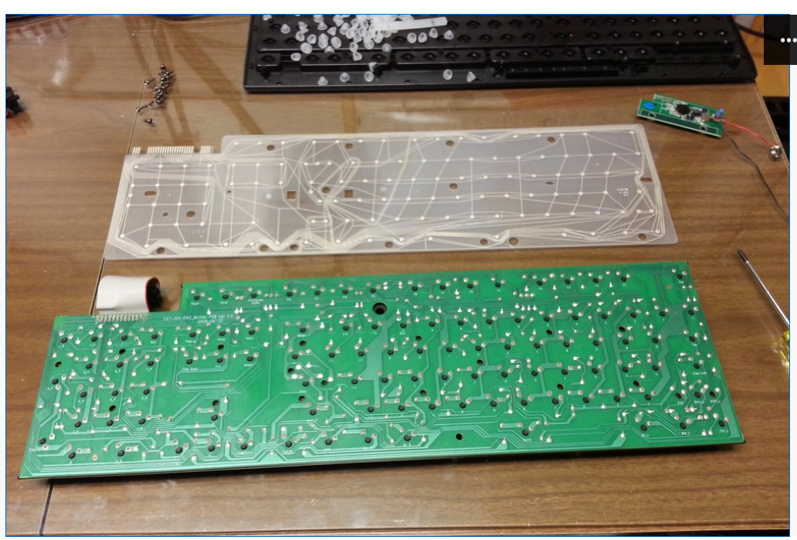

Figure 1. Keyboard Matrix Circuit beneath the keyboard cover

**1.4.1 Working of Keyboard**

In all keyboards, each circuit is broken at a point below each key. When you press a key, it presses a switch, completing the circuit and allowing a tiny amount of current to flow through. The mechanical action of the switch causes some vibration, called **bounce**, which the processor filters out. If you press and hold a key, the processor recognizes it as the equivalent of pressing a key repeatedly.

The keyboard consists of maximum 64 keys, which are interfaced with the CPU by using the key-codes. These key-codes are de-bounced and stored in an 8-byte **FIFORAM**, which can be accessed by the CPU. When the processor finds a circuit that is closed, it compares the location of that circuit on the key matrix to the **character map** in its read-only memory [(ROM)](https://computer.howstuffworks.com/rom.htm). A character map is basically a comparison chart or lookup table. It tells the processor the position of each key in the matrix and what each keystroke or combination of keystrokes represents. For example, the character map lets the processor know that pressing the **a** key by itself corresponds to a small letter "a," but the **Shift** and **a** keys pressed together correspond to a capital "A."

A computer can also use separate character maps, overriding the one found in the keyboard. This can be useful if a person is typing in a language that uses letters that don't have English equivalents on a keyboard with English letters. People can also set their computers to interpret their keystrokes as though they were typing on a Dvorak keyboard even though their actual keys are arranged in a QWERTY layout. In addition, operating systems and applications have keyboard **accessibility** settings that let people change their keyboard's behavior to adapt to disabilities.

All of the other types of switches used in keyboards are **mechanical** in nature. Each provides a different level of **audible** and **tactile** response -- the sounds and sensations that typing creates. Mechanical key switches include:

* 1. Rubber dome
  2. Membrane
  3. Metal contact
  4. Foam element

**Rubber dome** switches are very common. They use small, flexible rubber domes, each with a hard carbon center. When you press a key, a plunger on the bottom of the key pushes down against the dome, and the carbon center presses against a hard, flat surface beneath the key matrix. As long as the key is held, the carbon center completes the circuit. When the key is released, the rubber dome springs back to its original shape, forcing the key back up to its at-rest position. Rubber dome switch keyboards are inexpensive, have pretty good tactile response and are fairly resistant to spills and corrosion because of the rubber layer covering the key matrix.

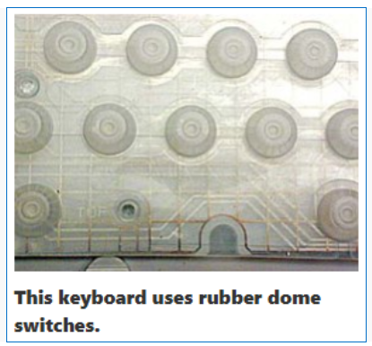

fi

figure 2. Keyboard rubber dome switches

Rather than having a switch for each key, **membrane** keyboards use a continuous membrane that stretches from one end to another. A pattern printed in the membrane completes the circuit when you press a key. Some membrane keyboards use a flat surface printed with representations of each key rather than keycaps. Membrane keyboards don't have good tactile response, and without additional mechanical components they don't make the clicking sound that some people like to hear when they're typing. However, they're generally inexpensive to make.

**Metal contact** and **foam element** keyboards are increasingly less common. Metal contact switches simply have a spring-loaded key with a strip of metal on the bottom of the plunger. When the key is pressed, the metal strip connects the two parts of the circuit. The foam element switch is basically the same design but with a small piece of spongy foam between the bottom of the plunger and the metal strip, providing a better tactile response. Both technologies have good tactile response, make satisfyingly audible "clicks," and are inexpensive to produce. The problem is that the contacts tend to wear out or corrode faster than on keyboards that use other technologies. Also, there is no barrier that prevents dust or liquids from coming in direct contact with the circuitry of the key matrix.

Video 1. What's inside a keyboard

**1.4.2 Keyboard Keys**

They Keyboard is the primary means of input for a computer. Most computer functions are triggered by key commands, many of which cannot be performed with the mouse alone.

**(i) Basic Keys**

The name “QWERTY” comes from the layout of the keys beginning with Q and ending in M. The letters are arranged by frequency of use in the English language with commonly used letters allocated to natural resting places of the hands on the keyboard.

Letters (Q,W,E,R,T,Y), Numbers (1,2,3,4,5), Symbols (!,@,#,$,%), SPACEBAR, (inserts a pause or “space”) and Arrows (←↑→↓) function primarily to input data, and do not have an extra function unless otherwise specified in a specific program or paired with another key.

BACKSPACE can be used to erase one letter behind the text cursor ( | ) in a field where text can be altered like a document or an email. Outside of this context BACKSPACE usually navigates to previous page or screen.

DELETE in the context of text will erase one letter in front of the text cursor. Outside of this context DELETE is usually used to delete a file.

ENTER (or RETURN) in the context of text will create a break in the document and begin a new paragraph. ENTER can also function as a confirm command or the equivalent of a mouse click if an object is highlighted. Some text fields, such as a status box on Facebook, will interpret a ENTER stroke as confirm, and not a break.

Depressing SHIFT while striking the ENTER key will not be interpreted as a confirmation and should create a break in this cases.

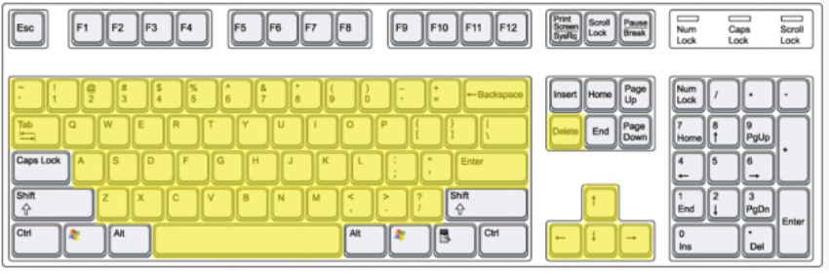

Figure 3. Basic keys of keyboard

**(ii) Modifier Keys**

When pressed these keys will input the character displayed at the bottom of the key, for instance the key labeled [! 1] will input the character [1] when pressed. When the SHIFT key is depressed at the same time the input will be the character on the top of the key, in this case [!].

SHIFT will also capitalize the input of letter keys. SHIFT also functions as a means to select continuous regions of data by depressing the shift key and using the arrow keys to create a region, such as in highlighting a sentence in a document like this.

Selecting regions is also possible with the CTRL key, but they don’t have to be continuous, like with this sentence. ALT does nothing on its own. ALT functions as an Alternating Key, triggering a secondary function of a different key, and is used with keyboard shortcuts (which we’ll cover later). This is often program specific.

CTRL does nothing on its own either and will trigger the secondary function of another key, just like ALT. CTRL usually triggers a system function such as printing. As with ALT this will be covered in Keyboard Shortcuts.

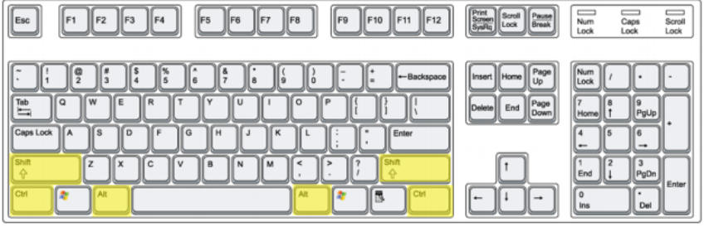

Figure 4 Modifier keys of keyboard

(iii) Other Keys

The NUMPAD is a secondary set of keys used for entering numeric data. They do not have any extra function, and exist just for convenience for inputting numerical data.

CAPS LOCK acts like a switch and will reverse the function of the SHIFT key’s effect on letters, inputting them as capital unless the SHIFT key is depressed.

NUM LOCK acts like a switch and is used to enable or disable the NUM PAD.

INSERT is used with inputting text and will set the computer in a mode that when toggled on will replace each letter ahead of the text cursor with what is typed. By default text is inserted with the text cursor, it does not replace text.

HOME will bring the text cursor to the beginning of a line.

END will bring the text cursor to the end of a line.

PAGE UP and PAGE DOWN will scroll a window up or down the equivalent of one screen.

PRTSCN (remember to depress SHIFT as well) “Print Screen” will perform what is called a “Screen Capture”, copying your entire screen, which you can later paste into a program like Microsoft Word.

Function keys are all contextual and usually pertain to advanced system maintenance, but not always. A casual user should have no reason to ever really use them. One good use of an Function Key to know is in regards with booting 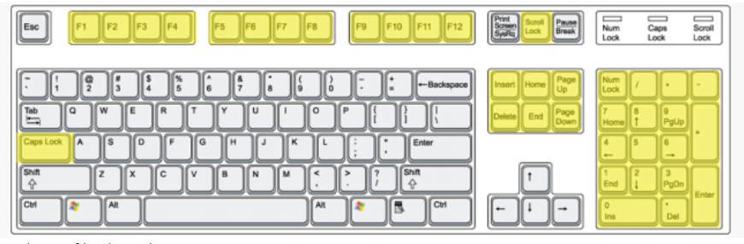your computer in SAFE MODE, which is a special setting meant for resolving critical errors like viruses or corrupted files. To trigger safe mode strike F8 when booting up, before Microsoft Windows opens.

Figure 5. Other keys of keyboard

**KEY BOARD SHORTCUTS**

A Keyboard Shortcut is a term used for pressing a modifier key with basic key in order to trigger a

secondary function of that basic key. When performing a Keyboard Shortcut you hold down the

modifier key and strike the basic key. Often Keyboard Shortcuts are program specific, especially

when the modifier key ALT is used.

(Where “+” means “press with”)

CTRL + Q = Quit (Exit a Program)

CTRL + W = Close Window

CTRL + A = Select All

CTRL + S = Save

CTRL + F = Find

CTRL + Z = Undo

CTRL + X = Cut

CTRL + C = Copy

CTRL + V = Paste

CTRL + P = Print

ALT + TAB = Switch windows

CTRL + ALT + DEL = Will bring up a menu allowing you to shut down, restart, or log off your computer. This will also allow you to launch Task Manager in order to monitor computer programs currently running on your computer and if need be stop them from doing so. A powerful tool if a program on your computer freezes.